COVID DRIVEN QUESTIONS FOR FUTURE BALANCE SHEETS – PART ONE
The 2008 financial crisis led to an in-depth review and critique of bank's balance sheets, and their appetite for risk. It led, amongst other things, to a requirement for higher capital reserves- and the need for recapitalisation.
So, what might the 2020 COVID 19 crisis tell us about the balance sheets of non-financial organisations- be they for profit or not for profit?
And how might it change our future view of risk management?
It might be showing us that the cash reserves and liquidity of many organisations are too low, having regard to the "black swan" risk that has just materialised. It might also be showing that levels of gearing are too high for such events.
How many of us have been part of "hypothetical" discussions in the past few years debating how many months’ costs should be held as cash reserves having regard to the expected probability of having nil income or income reduced significantly below what recent recessions have indicated would be appropriate, having regard to the particular sector in question? No doubt, the answer was typically “not very many” based on exceedingly low expectations that such an event would ever occur.
This requirement for cash reserves has also been coupled with the minimal returns being earned on cash deposits, making them unattractive to hold.
So, are we going to enter a future where organisations decide to keep higher cash reserves to manage future risks?
If this is the case, then as well as the impact of a period when organisations are having to rebuild their balance sheets to pre- COVID levels, consider the following
- what will this do to business investment in the short to medium term?
- how will that, in turn, impact the long -standing productivity challenges facing many businesses?
- what will it also do to the prospects of dividends being paid to investors?
Finally to pick up another theme from the 2008 Financial crisis, when considering this risk in the future, do Government bail-out schemes for businesses raise the same "moral hazard" arguments used in 2008 against banks- ie the default option for risk management is a government bail out?
The view on risk, and the moral hazard argument, may well depend, to mix metaphors, on whether the COVID 19 related lockdown is regarded as a "once in a blue moon" black swan?
Or is a bevy of black swans coming our way?

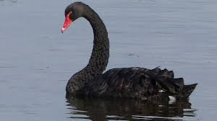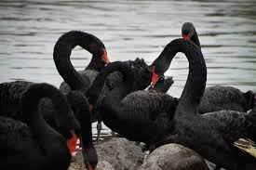
OR

So, as well as preparing our health systems and societies for future such events, we have some big questions to consider about the future financial liquidity of our businesses and managing associated risk.

